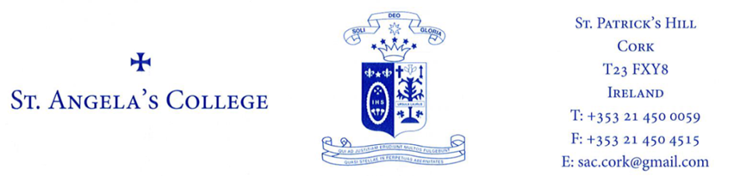

PRIVACY NOTICE FOR STUDENTS, PARENTS/GUARDIANS

By enrolling in and attending St Angela’s College you acknowledge that your personal data (including special category personal data) shall be processed by St Angela’s College. This Privacy Notice gives you some helpful information about who we are, what personal data we collect about you, why, who we share it with and why, how long we keep it, and your rights. If you need more information, please see our Data Protection Policy available at sac.cork@gmail.com

- Who we are:

We are St Angela’s College

Our address and contact details are St Patrick’s Hill, Cork City. Telephone: 021 4500059 or Email: sac.cork@gmail.com

We provide secondary level education

- The information we collect about you

When you are a student with St Angela’s College we collect and use your personal data.

The personal data we collect can include information about your identity and contact details; images/photo (including CCTV); family details; admission/enrolment details; previous schools; academic progress; PPS number; special educational needs; nationality; language; religion; medical data; information about behaviour and attendance; information about health, safety and welfare; financial information (re fees, grants, scholarships etc.); and other personal data.

If you are under 18 years when you enrol, we collect the name, address, contact details and other information about your parents/guardians. If you are under 18 years, your parent/guardian is consulted and asked to give consent for certain things like taking your photograph, going on school trips etc.

- How we use your information and the legal basis

We use your personal data for purposes including:
- Your application for enrolment;
- To provide you with appropriate education and support;
- To monitor your academic progress;
- To care for your health and well-being;
- To care for our staff and students;
- To process grant applications, fees and scholarships;
- To coordinate, evaluate, fund and organise educational programmes;
- To comply with our legal obligations as an education body;
- To comply with our monitoring and reporting obligations to Government bodies,
- To process appeals, resolve disputes, and defend litigation etc.
- Who we share your information with

We share your personal data with third parties, including other Government bodies.

This includes the State Examinations Commission, the Department of Education and Skills, NCSE, TUSLA, An Garda Síochána, HSE, the Department of Social Protection, the Revenue Commissioner. The level of sharing and the nature of what is shared depend on various factors. The Government bodies to which we transfer your personal data will use your personal data for their own purposes (including: to verify other information they already hold about you, etc.) and they may aggregate it with other information they already hold about you and your family. We also share your personal data with other third parties including our insurance company and other service providers (including IT providers, security providers, legal advisors etc), We are legally required to provide certain records relating to the progress of a student (under 18 years) in his/her education to the student’s parents/guardians, including results of examinations.

- We do not transfer your personal data to a third country or international organisation.

- We do not engage in automated decision making/profiling.

- How long we hold your data

Some personal data is only kept for a short period (e.g. we will destroy at the end of an academic year because it is no longer needed). Some data we retain for a longer period (e.g. retained after you leave or otherwise finish your studies with St Angela’s College, Example: State Examinations results.

- You have the following statutory rights that can be exercised at any time:

- Right to complain to supervisory authority.
- Right of access.
- Right to rectification.
- Right to be forgotten.
- Right to restrict processing.
- Right to data portability.
- Right to object and automated decision making/profiling.

- Contact

If you would like to discuss anything in this privacy notice, please contact Pat Curran, Principal at St Angela’s College.

