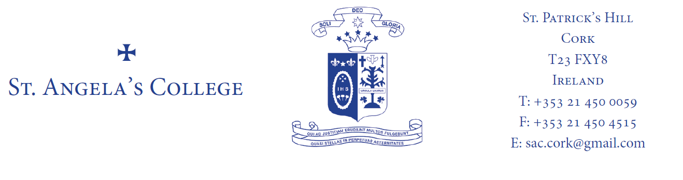

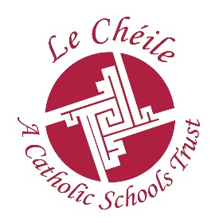
ST. ANGELA’S COLLEGE FIFTH YEAR

BOOK LIST 2019-2020
RELIGION: Life Matters. Niall Boyle (Mentor Publications)

IRISH: Fiuntas Nua (Ardleibhéal) (Edco) Yvonne O’Toole, Elizabeth Wade. ‘Gafa’ Ré Ó Laighléis (Ardleibhéal)
Fuinneamh Gnathleibhéal, (Edco) Yvonne O’Toole, Elizabeth Warde

ENGLISH: Higher Level:King Lear Edco: ISBN 978184536
New Explorations – John G Fahy Gill Education ISBN: 9780717172863
Revolutions Higher Level Paper 1 – Textbook & Portfolio Book Pack ISBN: 9780714424637 C. J. Fallon
Ordinary Level – to be advised
Chambers Thesaurus – all levels

MATHS: Active Maths 4 Book 1 & 2, 2nd Edition 2016 – Michael Keating, Derek Mulvany, Oliver Murphy, James O’Loughlin – Folens (Higher Level)
Destination Maths: Louise Boylan & Aisling Quirke - Gill Education (Ordinary Level)

ART: Appreciating Art 2nd Edition Áine Ní Chárthaigh & Aiden O’Sullivan (Gill Education)
Less Stress More Success- Aine Ni Chárthaigh – New Version
- A3 & A2 Sketchpads
- A2 plastic folder
- A2 paper folder
- 6B,5B,2B,4B,HB pencils
- Student quality watercolour pencils
- Small, medium & large paintbrushes
- Putty Rubber
- Paints – watercolour / acrylic
- Fine Liner felt tip pen – black

ACCOUNTING: Accounting for Senior Cycle (Third Edition). Christy Tyrell & David Kielthy (Edco) the book has a green cover

BUSINESS: 21st Century Business. William Murphy (C J Fallon) 3rd Edition Published March 2018
Edco Higher level exam papers(Red Book) LC Business

CHEMISTRY: Chemistry Live, Textbook & Workbook (Second Edition) Declan Kennedy. (Folens)
Leaving Certificate Chemistry Student Laboratory Notebook.
(Second Edition) Declan Kennedy. (Folens)
Edco Exam Paper

FRENCH: Tout Va Bien. THIRD Edition - Dervla Murphy. (Folens) + Écoutez Bien 2 (Higher Level ONLY)
Keep Bien Dit from T.Y,
Clé a la Grammaire – Educate.ie

GEOGRAPHY: Horizons 2nd Edition Book 1 Tara Fitzharris Folens

PHYSICS: Investigating Physics: Andrew Kenny / Gill & McMill
Maths Tables (Log Book)
Project Maths Copy
Practical Physics / M. Crowe (Fallons)
Ring folder & A4 Pad

HISTORY: Modern Europe and the Wider World - FOURTH Edition
Dermot Lucey. (Gill and MacMillan)
Modern Ireland. Gerard Brockie & Raymond Walsh (Gill & Macmillan)THIRD Edition

BIOLOGY: Leaving Cert Biology Plus 2013
Michael O’Callaghan. (Edco)
A4 Hardback Science copy with graph paper
Edco Exam Papers, Higher & Ordinary, (yellow book)
Essentials unfolded. Leaving Cert Biology, Higher & Ordinary, Mona Murray. The Celtic Press

HOME ECONOMICS: Complete Home Economics
Authors:Leanne Gillick and Lauren Healy
Complete Home Economics Food Studies Assignment Guide
Authors:Leanne Gillick and Lauren Healy Educate.ie

GERMAN: Deutsch Komplett
Maire Devlin Quinn & Derval Mcgrath (Folens)
Edco Exam Papers

MUSIC: Manuscript
Book approx. €52.00 bought directly from authors in September through the school

SCHOOL JOURNAL Available in school in September

