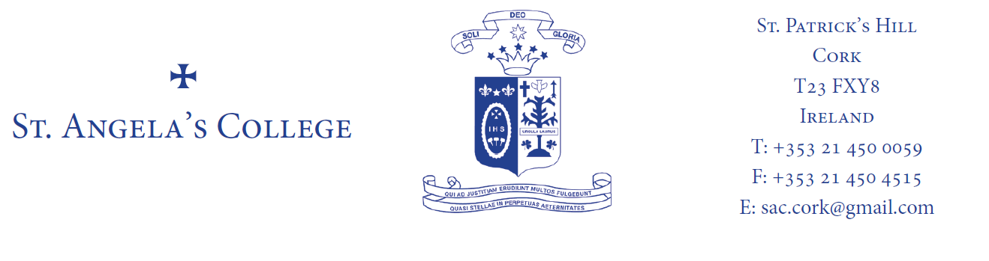

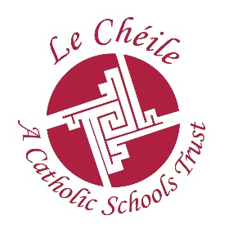
ST. ANGELA’S COLLEGE THIRD YEAR

BOOK LIST 2019-2020

RELIGION: Retain from 2nd year.

ENGLISH: Make Your Mark! – Textbook & Handbook by Sarah Chambers & Emily Lewis (Folens) Carried over from 2nd Year
Romeo & Juliet – Textbook & Portfolio – Catherine O’ Donovan (Educate.ie)
Skills for Exam Success Higher Level English by Pauline Kelly. ISBN: 9780717180998 (For both Higher Level AND Ordinary Level Students)
Edco Exam Papers

MATHS: Retain 2nd year Book
Edco Exam Papers

FRENCH: Keep Ca Roule 2

IRISH Keep book from 2nd year
Edco Exam Papers

HOME ECONOMICS Keep book from 2nd year

ART A2 plastic folder with handle set of watercolour pencils
A3 sketchpad, 2B, 4B, 5B, HB pencils, small, medium & large paintbrush, set of paints (watercolour, gouache or acrylic) putty rubber

GERMAN Deutsch Für Alle 2 (Folens) Máire Devlin Quinn & Derval McGrath
GEOGRAPHY Edco Geography Exam Papers and Retain book from 2nd year
HISTORY Red Edco History Exam Papers
SCIENCE Retain from 2nd year
MUSIC: Edco Music Exam Papers
CSPE Retain from 2nd year
SPHE My Life 3 Author Stephanie Mangan (Folens)
SCHOOL JOURNAL Available in school in September

