St Angela’s College
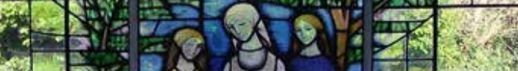

First Year Enrolment Application Form 2021

Please complete in BLOCK CAPITAL
STUDENT INFORMATION
Surname: ________________________ Christian Name: _________________________ Student PPS No: _____________
Address: ________________________________________________________________ Post code: __________________
Date of Birth: ___________________________
Religion: _______________________ Nationality: ______________________ Country of Birth: _____________________
Parent E-mail address(s): ________________________________________

Name and Address of present Primary School: ______________________________________________________________
Name/s of sister/s currently attending St Angela’s College:
- Name: _______________________________________ Date of Birth: _________________ Class: ________________
- Name: _______________________________________ Date of Birth: _________________ Class: ________________
- Name: _______________________________________ Date of Birth: _________________ Class: ________________
Name/s of sister/s previously in St Angela’s College ________________________________________Year of L.C_______
Name of mother who attended St Angela’s College ________________________________________ Year of L.C_______
(Mother’s Maiden name)
PARENT/GUARDIAN DETAILS
Name of Mother: ____________________________________________________ Mobile No: _______________________
Name of Father: _____________________________________________________ Mobile No: _______________________

SPECIAL EDUCATIONAL NEEDS
Does your daughter have a Special Education need? Yes No
Please specify: ________________________________________________________________________________________
____________________________________________________________________________________________________
Does your daughter hold an Irish Exemption? Yes No
If you answered YES, a copy of the exemption granted through the Primary School must be provided following an offer and acceptance of a place in St Angela’s College
I certify that the above information is correct and I wish to have the above-named child considered for registration in St Angela’s College.
Signature (1) _____________________________ (2) ________________________________ Date: ____________________
Parent/Guardian Parent/Guardian

