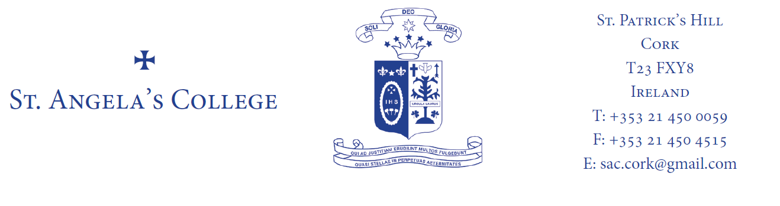

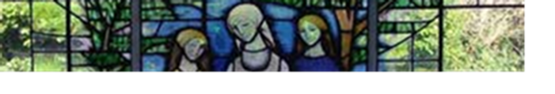

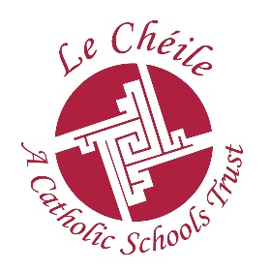
ST. ANGELA’S COLLEGE FIRST YEAR

BOOK LIST 2023 - 2024

CORE SUBJECTS

RELIGION: A Question of Faith (Textbook and Workbook), Niamh McDermott and Lori Whelan, (Edco)
Good News Bible (Veritas)

GAEILGE: Turas 1 An Dara hEagrán (Textbook & Leabhar Gníomhaíochta/Punann). Risteard MacLiam. (educate.ie)

ENGLISH: Dive In. Fiona Kirwan and Edel O'Donovan. (Folens)

MATHS: Maths kit from school: €27.50 payable to the school in September (Calculator is included in this price)
New “Connect with Maths Introduction to Junior Cycle” John McKeon, Gillian Russell & Michelle Kelly (Edco)

FRENCH: En Avant! Junior Cycle French Textbook and Workbook (Mon dossier) Liz Shinners & Liz Benson. (Edco)

HISTORY: Making History: Complete Junior Cycle History SECOND EDITION Textbook and Skills book, Dermot Lucey and Stacy Stout (Gill Education)

GEOGRAPHY: Living Geography Book and Workbook Dermot Lucey and Jimmy Condon (CJ Fallon)

SCIENCE: Essential Science textbook, SECOND EDITION, Declan Kennedy, Rose Lawlor & Seán Finn (Folens)
Student Laboratory Notebook and Assessment Skills, SECOND EDITION, Declan Kennedy, Rose Lawlor & Seán Finn. (Folens)
One A4 size Science hard cover copy with graph paper.

CSPE: Make a Difference 5th Edition - Text book & Student Activity Book. Conor Harrison & Mairín Wilson. (Folens)

SPHE: Health and Wellbeing SPHE 1. (Edco)

NURTURE WELLBEING: Book ordered by the school. Payment will be requested when books are handed out in September.

OPTIONAL SUBJECTS
Students will need to buy books for the two optional subjects they are studying.

(TECHNICAL) GRAPHICS Book and Graphics set will be ordered by the school. Payment will be requested when items are handed out in September.

ART: 30 Euro for Art Pack -This can be paid through the School App in September. This includes - Folder, sketchbook, pencils, colouring pencils, paints and brushes. Please purchase: Pritt Stick, Scissors, Ruler, Eraser.

BUSINESS STUDIES: Enterprise Textbook and Activity Book, Caroline McHale & Lisa Young (Gill Education)
Hardback A4 notes copy
Calculator
Premier A3 Mesh Bag / Wallet

GERMAN: Alles Klar (a complete course in Junior Cycle German) Declan Webb (educate.ie)

HOME ECONOMICS: @Home SECOND EDITION (3 book pack – textbook, activity book and practical /recipe book) Eilis Flood. (educate.ie)
2 Manuscript copies - soft cover A4 in size

MUSIC: Maestro, Nathan Barrett, (educate.ie)
Manuscript copy
Recorder.

SCHOOL JOURNAL: Available in school in September

ADDITIONAL SUGGESTIONS FOR ALL FIRST YEARS

Name tags for all school clothing & books/copies
B4 Mesh zipped folders for all subjects – in a variety of colours
Permanent black marker
Black, blue and red pens. No clicker pens please
A selection of A4 Hardback copies and Plastic, soft-cover A4 copies (at least 6 of each suggested)
A4 writing pad, wide lined with margins
Plastic pockets (pack of 40 minimum)
Dividers
A selection of highlighter pens

