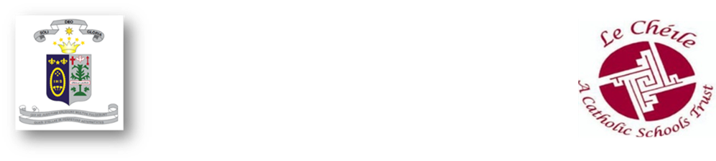
St. Angela’s College

Courtesy, Kindness & Respect



Curriculum Overview

Reviewed

18th December, 2023

This Curriculum Overview has been devised and published by the Board of Management of St Angela’s College ('the College') following collaboration and consultation with the following partners and interested parties:

- The Trustees of the College( `Le Chéile Trust`)
- The Teaching staff of the College
- The Parents' Association of the College.
- The Students' Council of the College.

St Angela’s College is a voluntary Catholic College which upholds the Ethos and traditions of the Ursuline Order within the Le Chéile Schools' Trust as set out in its Charter.

St Angela’s College Mission Statement

St. Angela’s College is an Ursuline Catholic Voluntary Secondary School within the Le Chéile School Trust and is committed to “nurturing the uniqueness and full potential of both students and staff in a happy, caring and disciplined learning environment and also promoting respect and responsibility for self, for others and for the greater community in the light of Ursuline, Christian values”.

Ethos and Promoting Positive Behaviour
Students of St Angela’s College are expected, at all times, do their best to live according to the school’s Christian values/ethos. Students are expected to;
- Act justly
- Be honest and truthful
- Be respectful in their interactions with to teachers, fellow pupils, parents/guardians, secretary, caretaker and visitors to the school.
- Be courteous and concerned for their own good the good of others
- Observe good manners at all times
- Show respect for their environment
- Co-operate actively in the community of St. Angela’s College

Guided by these virtues, and dedicated to the pursuit of excellence, we aim, at all times, to provide a safe, caring, inclusive learning environment for all our pupils.
To provide such an environment, we are committed to promoting and acknowledging positive behaviour and to developing a school community in which all its members, pupils, staff, parents/guardians, and Board of Management treat each other with gentleness and respect.

- Preface

Our primary aim in St Angela’s College is to provide an environment where each of our students can develop to their full potential. The school prides itself on its well-earned record of academic excellence, but we believe that it is equally important that the social, physical, emotional and spiritual needs of every student are met in order that she leaves our school a young adult, capable of dealing in a mature manner with the challenges which will face her in the third millennium.

- Structure
We have a five- or six-year cycle based around two compulsory and one optional programme which form the scaffold of the curriculum. These programmes are:
* The Junior Cycle Programme (First, Second and Third Year)
* The optional Transition Year Programme (Fourth Year)
* The Leaving Certificate Programme (Fifth and Sixth Year)
In all three of these programmes we offer a range of subjects that allows for the maximum possible amount of student choice.

The academic school year is divided in to three, 11-week Teaching, Learning and assessment cycle (See appendix 1). The T.L.As were designed to give a clearer structure to the school year and a greater consistency across all subjects. It is also an initiative to improve student wellbeing. It's a great opportunity to get departments planning curricular content and assessments at the same time and to collaboratively plan assessments that align with the Junior Cycle Learning Outcomes

2.1 The Junior Cycle Programme
A varied and wide range of subjects is available to students at Junior Cycle level. Students must take examinations in English, Irish and Maths at a level that is appropriate to their ability and aptitude. Attainment levels in the school are very high. Provision is also made for students who may have learning difficulties and learning support programmes are available in line with student needs and school resources. Students will be granted an Irish exemption if they meet the criteria as outlined in Circular 0055/2022.

The following subjects are studied by all students at Junior Cycle:
Core Subjects:
- Gaeilge
- English
- Mathematics
- History
- Geography
- French or German
- Science
- Religious Education
- Wellbeing incorporating 400 hours as outlined in Circular 0059/2021;
  - Civics, Social and Political Education
  - Physical Education
  - Social, Personal and Health Education
  - Nurture
  - Digital Literacy

Choice Subjects: Students will choose two further subjects from the following list:
- Business Studies
- Home Economics
- Music
- Art
- Graphics

By way of illustration of the "setting" procedure for the Choice Subjects, the first- and second-year subjects were arranged in 2023/2024 as follows:

First Year
A | Business | Home Ec. | Music | Science
B | Home Ec. | Science | Science | V. Art
C | Business | Home Ec. | Science | Graphics

Second Year
A | Art | Music | Science | Home Ec. | Business
B | Art | Science | Home Ec. | Business
C | Science | Science | Graphics | Business

2.2 Transition Year
The Transition Year Programme was introduced in St Angela’s College in 1995 and since that time, the programme has evolved into a broadly-based educational experience, which we believe is both challenging and enriching for student and staff alike. Students entering the senior cycle have the option of taking Transition Year.
In devising our programme we have at all times borne in mind that the primary purpose of the year is to assist each girl in the process of maturation. The Transition Year programme has six principle aims:

1. To prepare our students for their role as participative and responsible members of society.
2. To enable our students to take a greater responsibility for their own learning and decision making.
3. To help our students to develop a range of critical thinking and problem solving skills.
4. To provide opportunities for our students to gain an insight into the world of work.
5. To give our students a solid foundation for Leaving Certificate studies.
6. To enable our students to increase competence in areas of weakness.
7. To challenge our students to avail of opportunities to learn in divergent contexts.

A full evaluation and revision of the Transition Year Programme takes places annually. A written programme for all areas of study is available in the school. It should be emphasised however that the programme is in a constant state of evolution and, indeed, no two successive years have ever been the same.
The following areas of study are available to students during Transition Year:
- Gaeilge
- English
- Mathematics
- Modern Foreign Language (French/German)
- History
- Physics/Chemistry/ Biology/Agricultural Science
- Accounting /Business/Economics
- Home Economics
- Design and Communication Graphics
- Art
- Religious Education
- Physical Education
- S.P.H.E
- Personal Development (Life skills)

A range of other courses is also offered to Transition Year students, intended to broaden their educational experience. These vary from year to year depending on student choice but typically they include:
- Developmental studies
- Mini-company
- Creative crafts
- First Aid
- Film and Media Studies
- Reading Revolution/Junk Kouture/ Young Social Innovators/Amber Flag
- Nutritional studies
- Ursuline heritage
- History of feminism
- Law
- Drama, Film and media studies
- Chinese/Japanese
- Italian
- Community
- Environmental studies
- Communications
- Psychology
- Project Management
- Wellbeing- Learning to Learn
- Podcasting

Other important elements of the Transition Year Programme in our school include:
- A two-week Work Experience programme
- A Community Care Programme
- GAISCE - the President's Award
- Outdoor Pursuits
- Excursions (theatre, cinema etc.)
- Seminars, visiting speakers etc.
- Special events (e.g. table quiz, songwriting workshop)
All Transition Year students sit the T.L.A examinations in their core subjects at Christmas and summer. Certification for students completing the Transition Year Programme is provided at three levels: Pass; Pass with Merit and Pass with Distinction.

2.21 Career Interest - Aptitude Assessment

All students must complete the EirQuest and Cambridge aptitude and interest testing in Transition Year. We feel that making an informed choice about their Leaving Certificate optional subjects is incredibly important, both for the students’ academic interest and progress in school, and also for creating opportunities for course and career choice applications in the future. The results are analysed and interpreted to identify students’ strengths, their interests, career goals and occupational choice in conjunction with their initial fifth year subject choices.
Each student will receive the following booklets linked to the EirQuest and Cambridge aptitude and interest testing:
1. Aptitude Test Results Report
2. Aptitude Test Workbook
3. Subject Choice Information Booklet
5. Access to their personalised MyCareersRoom online.

This information is supplemented an information meeting with the TY student and their parent/s.

- Leaving Certificate
A very extensive range of subjects is available to students at Leaving Certificate level. The Choice Subjects are arranged in three sets with the student taking one subject from within each set. The sets are arranged to allow the optimum number of students to take the subjects they wish to study. The following subjects are available to students at Leaving Certificate level:
Core Subjects:
- Gaeilge
- English
- Mathematics
- Career Guidance
- Religious Education
- SPHE
- Physical Education
- Modern Foreign Language (French or German)
Choice subjects:
- Accounting
- Art
- Business
- Chemistry
- Home Economics
- Geography
- German
- History
- Physics
- Music
- Economics and Agricultural Science are offered to Senior students outside of school time.
- Design & Communication Graphics

Fifth Year subject choice is conducted in Transition Year using our Administration software, Vsware. Students are allowed to have free selection of subjects in the first phase of the process. Every effort is made to accommodate the requests of students.

By way of illustration of the "setting" procedure for the Choice Subjects for fifth years, in 2023/2024 the subjects were arranged as follows:

Fifth Year
A | Geography | Biology | Music | Chemistry | History
B | Biology | Biology | Physics | Business | Home Ec. | D.C.G
C | Biology | Business | Art | Accounting | Chemistry
D | French | French | French | German | German
Irish | Irish | Irish | Irish | Irish | Business

- Students with an Irish/Modern language Exemption

  - Irish exemptions are processed in accordance with Circular 0055/2022 (this Circular supersedes Circular M10/94, the 2008 revision of that Circular and Circular 0053/2019) and will only be granted in exceptional circumstances. Existing exemptions from the study of Irish granted under Circulars 12/96, M10/94 and Circular 0053/2019, and held by students will continue to apply until the end of their post-primary education.
Exemption from the study of Irish may be allowed in the following exceptional circumstances only:
- Students whose education up to 12 years of age (or up to and including the final year of their primary education) was received outside the State (for a minimum period of three consecutive years) and where they did not have opportunity to engage in the study of Irish
- Students who:
i.) present with significant learning difficulties that are persistent despite having had access to a differentiated approach to language and literacy learning over time (Irish and, or, English). Documentary evidence to this effect, held by the school, should include Student Support Plans detailing:
- Regular reviews of learning needs as part of an ongoing cycle of assessment
- Target-setting
- Evidence-informed intervention and review, including test scores (word reading, reading comprehension, spelling, and other scores of language/literacy) at key points of review.
and
ii.) at the time of the application for exemption present with a Standardised Score on a discrete test in either Word Reading, Reading Comprehension or Spelling at/below the 10th percentile.

iii.) A student who experiences a high level of multiple and persistent needs that are a significant barrier to the student’s participation and engagement in their learning and school life

  - If a student is granted a Certificate of Exemption from the study of Irish, the school will facilitate the student in the following ways:

4.21 Junior Cycle students
First year students remain in their Irish class and study, unless withdrawn for learning support. In the academic year 2023/2024 students with an Irish Exemption will partake in a program for a proposed Course, ‘Organisation and Study Skills’.

In second- and third-year students will be withdrawn for learning support during class time for Irish. If this is not possible for logistical reasons, the students will remain in the Irish class and study.

4.22 Senior Cycle Students
In 2018, another optional subject, in this case Biology was added to the Irish block in fifth year. All students entitled to an Irish Exemption under the relevant circulars will take Biology at this time. The optional subject added to the Irish block may change year to year depending on the staffing allocation and student demand.
An NUI exemption does not supersede the conditions of Circular 0055/2022. Therefore, students in receipt of an NUI exemption are expected to study Irish up to Leaving Certificate.

  - Modern Foreign Language Exemption
This exemption is granted by the NUI for the purposes of University entry requirements and is not linked to Circular 0055/2022. Therefore students with an NUI exemption in a modern foreign language will be given an option to drop the relevant subject in sixth year.

- Subject reductions (See appendix 2)
  - Junior Cycle
A subject reduction at Junior Cycle can be granted to meet the Special Educational needs of students only in exceptional circumstances and on a case by case basis.

  - Senior Cycle

5.2.2 All fifth year students must study the full curriculum offered in St Angela’s College.
5.2.3 A subject reduction at Senior Cycle can only be granted to meet the Special Educational needs of students with a standard score of eighty-five or below. In fifth year, students with special educational needs who are on reduced subjects may be withdrawn for subject support, otherwise they will remain in class and study.

The school is very proud of the achievements of our students in the Leaving Certificate Examinations over many years. Many of our girls have won prestigious University scholarships and, perhaps even more significantly, attainment of places on third level courses in either the Universities or Institutes of Technology is near universal.

This policy was reviewed and ratified by the Board of Management of St Angela’s College at its meeting on 18/12/2023
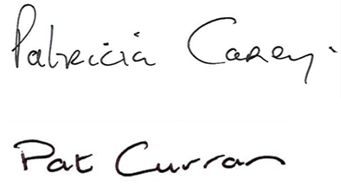

Signature: ______________________________ Date: 18/12/2023
Chairperson, Board of Management

Signature: ______________________________ Date: 18/12/2023
Principal

Appendix 1

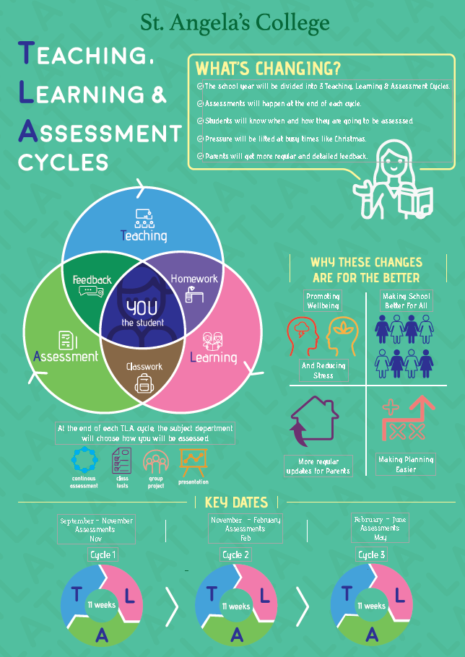
Appendix 2

